**PROJECT 3**

Janhvi Mishra

**Integrate Grafana with Linux Server for high cpu utilization and Create graph in Grafana**

# **INTRODUCTION**

**What is Grafana?**

Grafana is an open source interactive data-visualization platform, developed by Grafana Labs, which allows users to see their data via charts and graphs that are unified into one dashboard (or multiple dashboards!) for easier interpretation and understanding. You can also query and set alerts on your information and metrics from wherever that information is stored, whether that’s traditional server environments, Kubernetes clusters, or various cloud services, etc. You’re then more easily able to analyze the data, identify trends and inconsistencies, and ultimately make your processes more efficient. Grafana was built on open principles and the belief that data should be accessible throughout an organization, not just to a small handful of people. This fosters a culture where data can be easily found and used by anyone who needs it, empowering teams to be more open, innovative, and collaborative.



# **STEPS**

* Sign in to AWS management console.
* Go to search bar and search for EC2 instance and click on create instance.
* Add name of the instance, application(ubuntu), instance type(t2.micro).

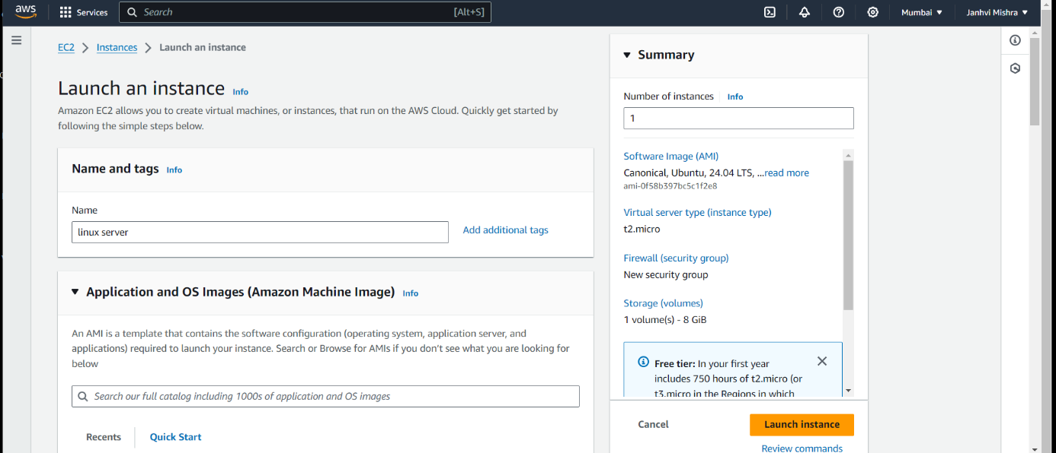

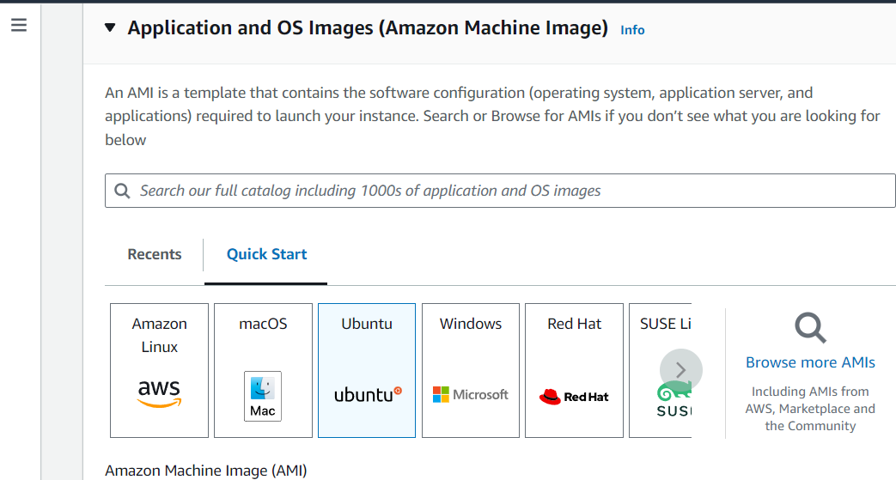

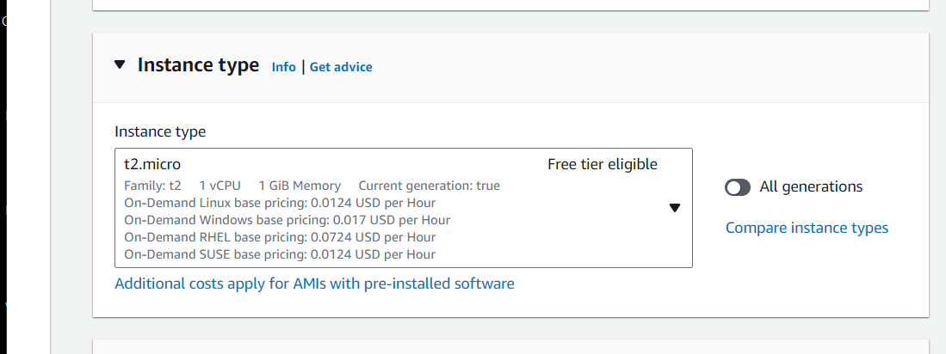

* Create new key pair. Write the name of the keypair and the click on ppk.
* Then click on create keypair.

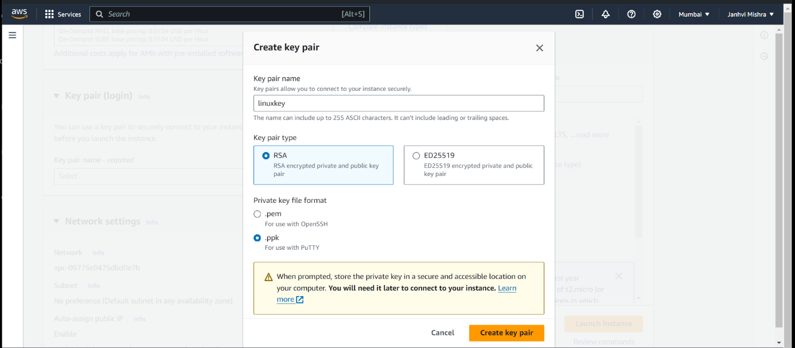

* Remaining all the setting will be default.
* Click on launch instance.
* Copy your public ip and paste it in putty and add key by browsing it in ssh -> auth -> credential.

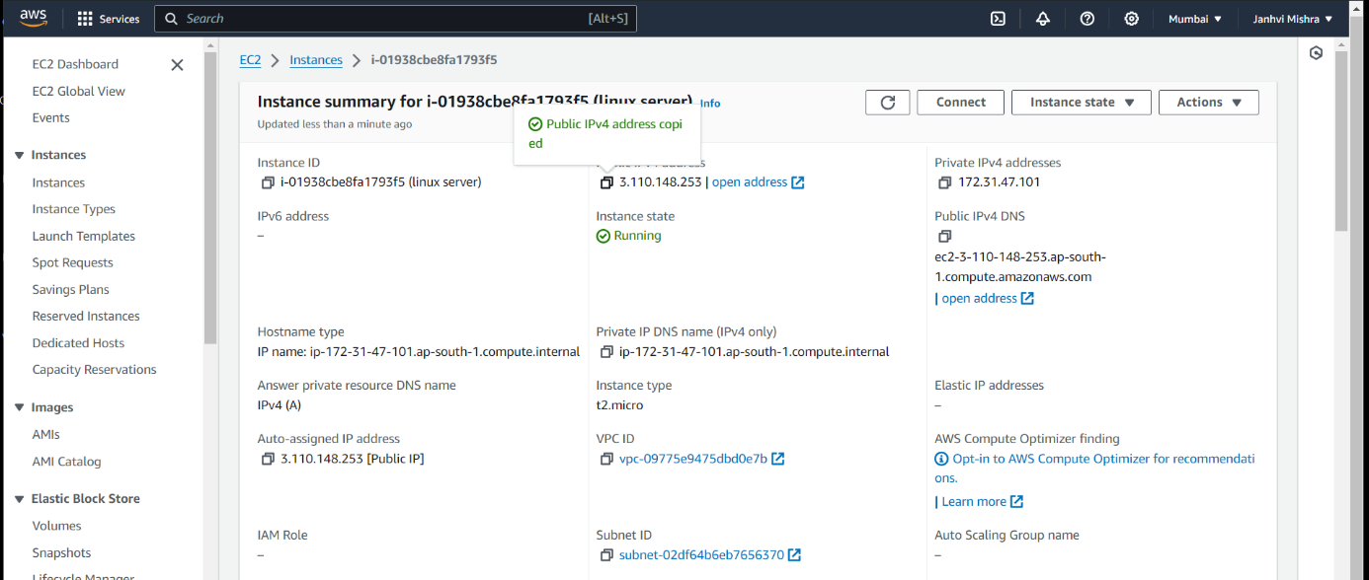

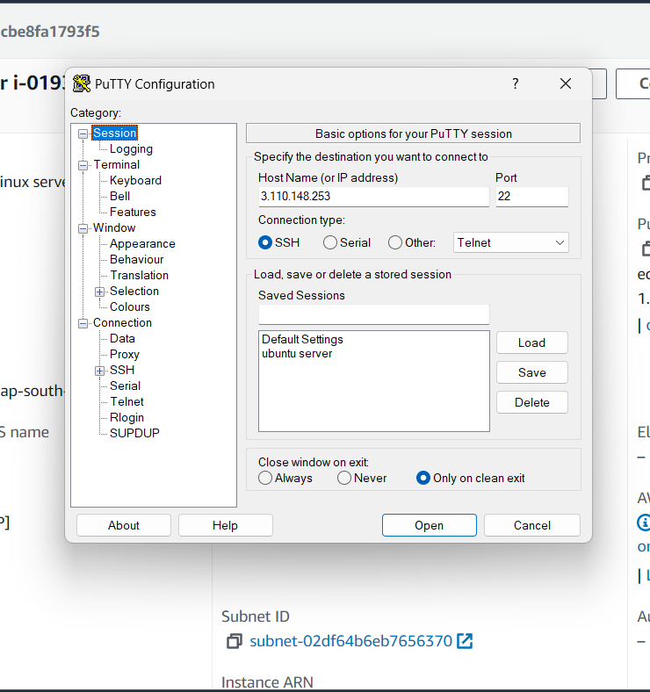

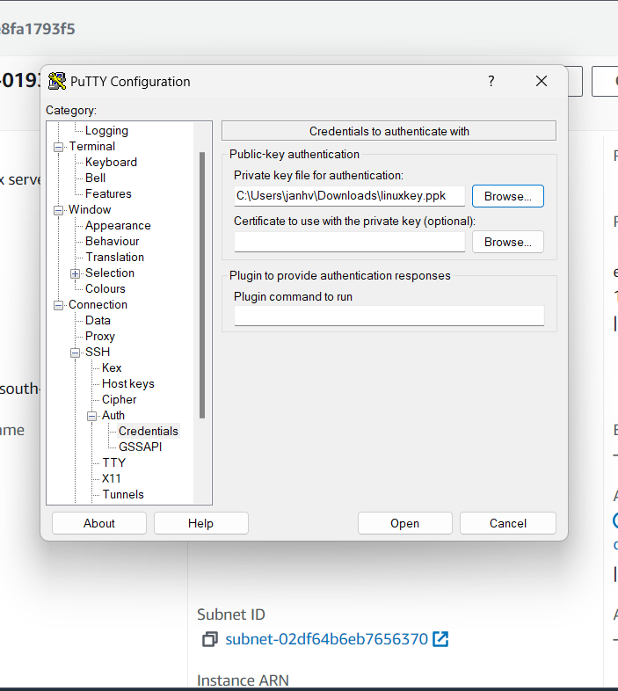

* Then your linux terminal will be opened.
* Login as ubuntu.
* Then copy paste the following commands one by one by typing sudo su command:

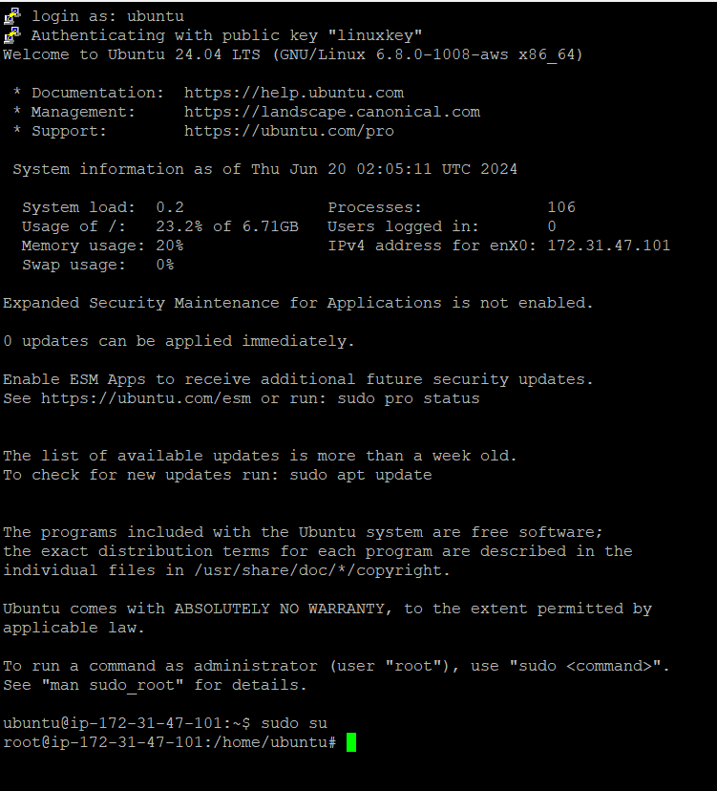

sudo apt update -y && sudo apt upgrade -y

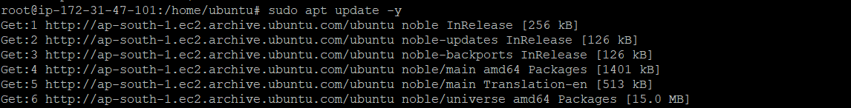

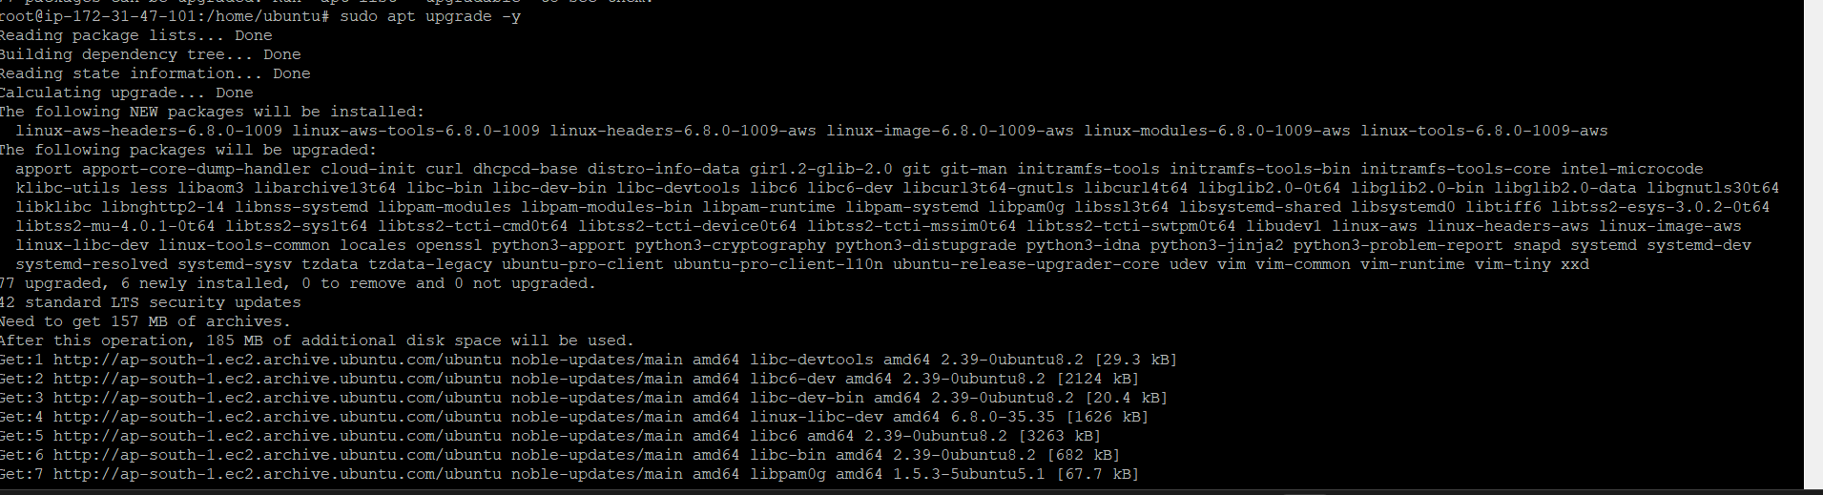

sudo apt install -y apt-transport-https software-properties-common wget

sudo mkdir -p /etc/apt/keyrings/

wget -q -O - https://apt.grafana.com/gpg.key | gpg --dearmor | sudo tee /etc/apt/keyrings/grafana.gpg > /dev/null



echo "deb [signed-by=/etc/apt/keyrings/grafana.gpg] https://apt.grafana.com stable main" | sudo tee -a /etc/apt/sources.list.d/grafana.list



sudo apt update

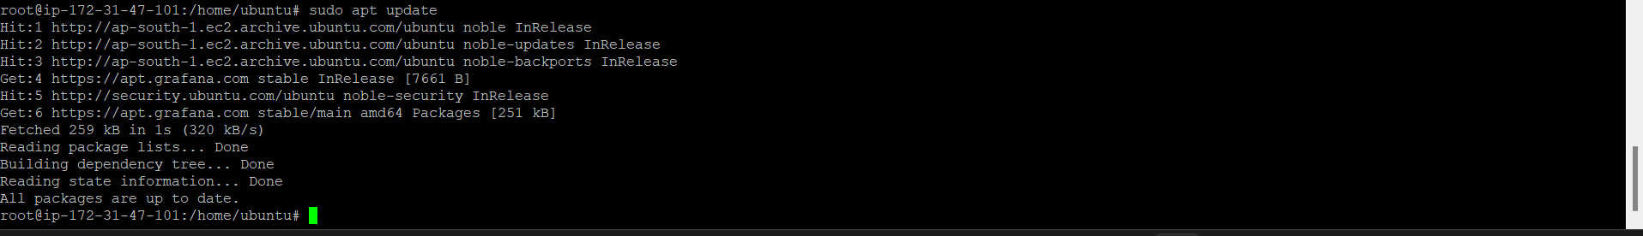

sudo apt install Grafana

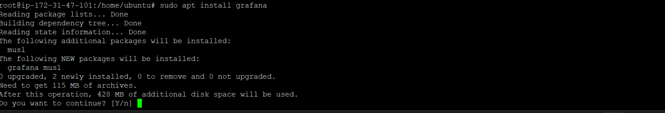

sudo grafana-server -v



sudo systemctl enable grafana-server



sudo systemctl start grafana-server



sudo systemctl status grafana-server

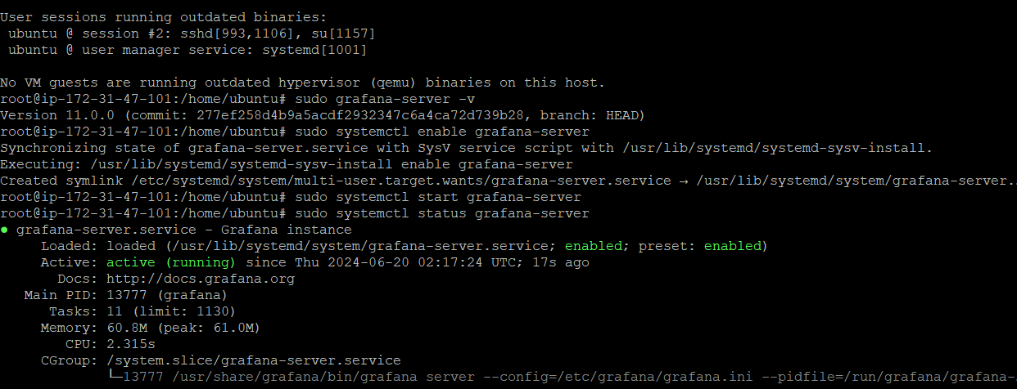

sudo ufw enable

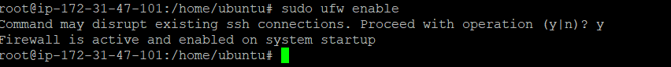

sudo ufw allow ssh

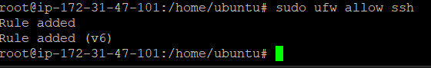

sudo ufw allow 3000/tcp

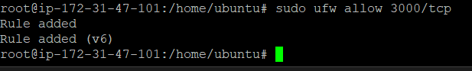

**After running these codes browse your server ip along with 3000.**

<http://your_server_IP:3000>

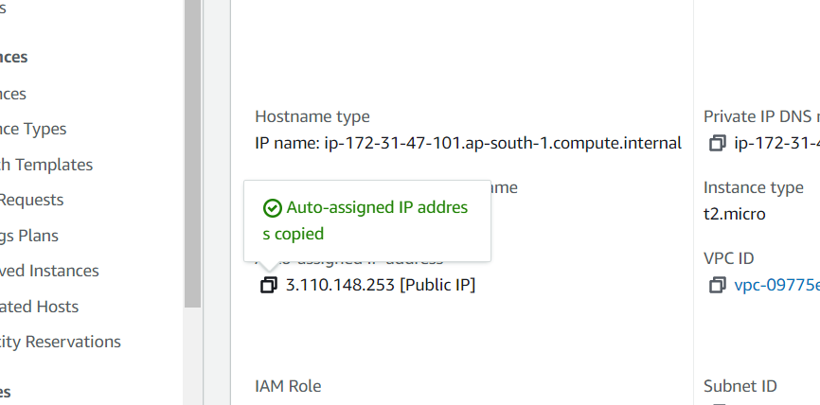

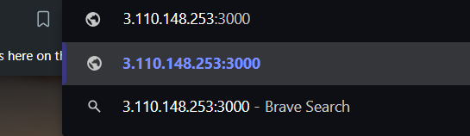

* Username: admin
* Password: admin

**You'll be prompted to create a new password. Input a secure password, confirm it, and click the "Submit" button.**

**Now we have to create an IAM policy**

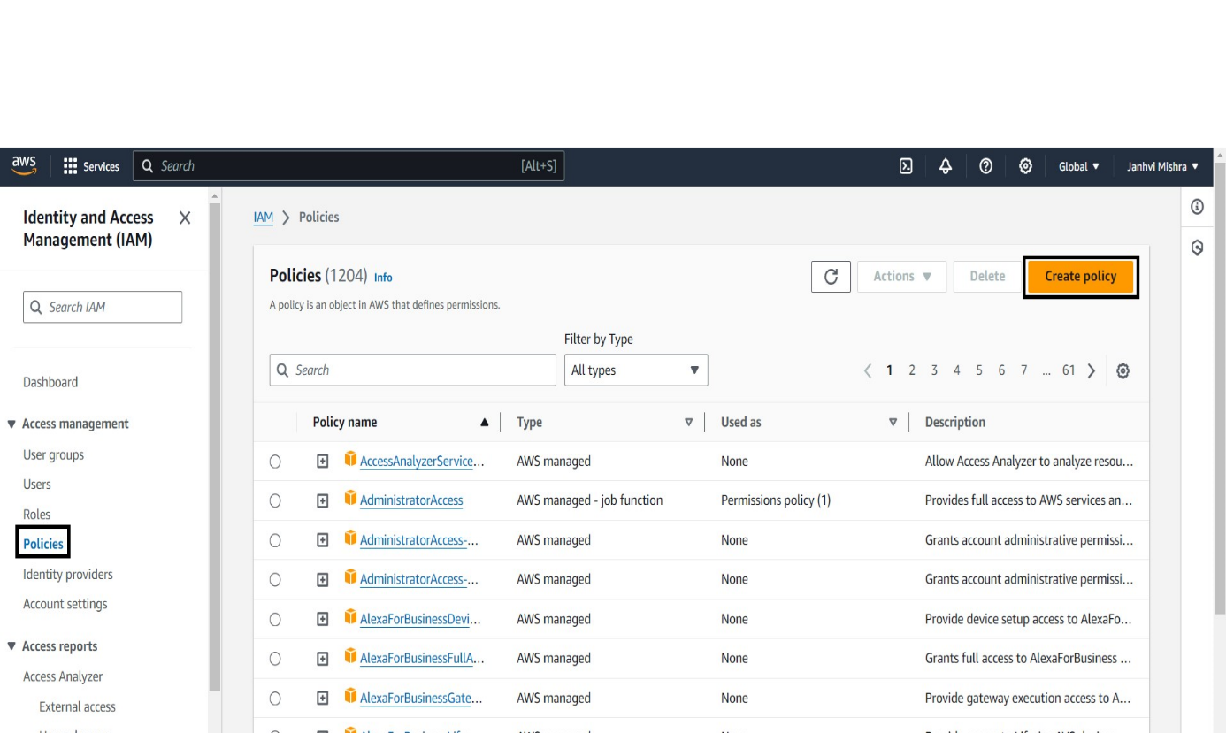

* Under the services search cloud watch.

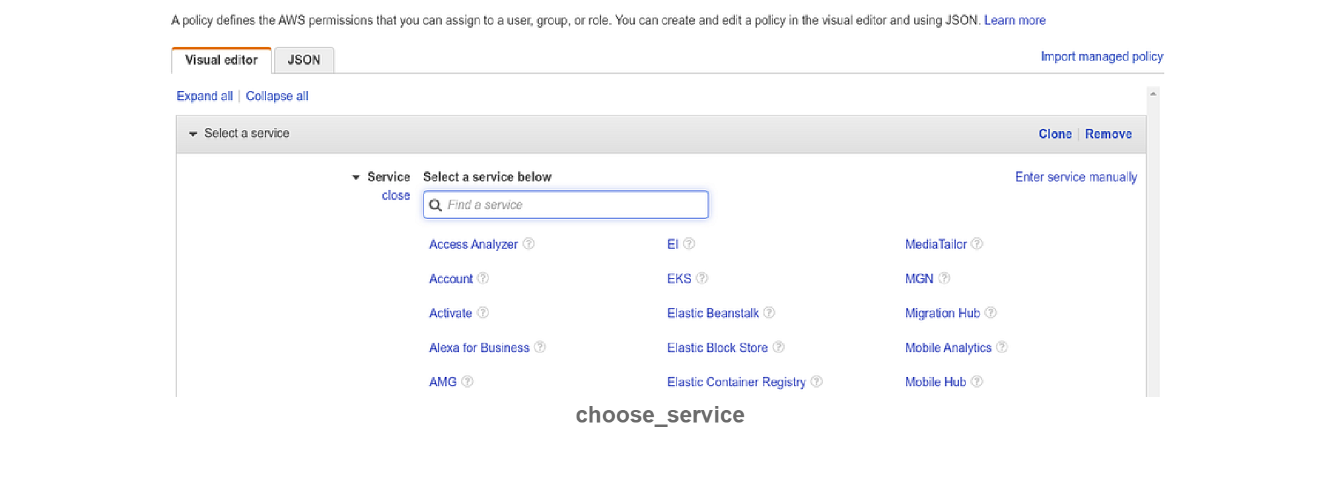

**Now after creating IAM policy we need to create IAM role by going to left panel and selecting role option.**

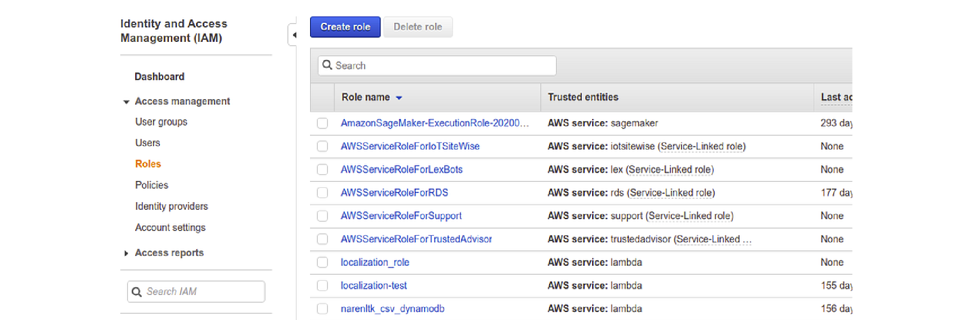

* Select AWS service ->EC2 (under case) ->next: Permissions

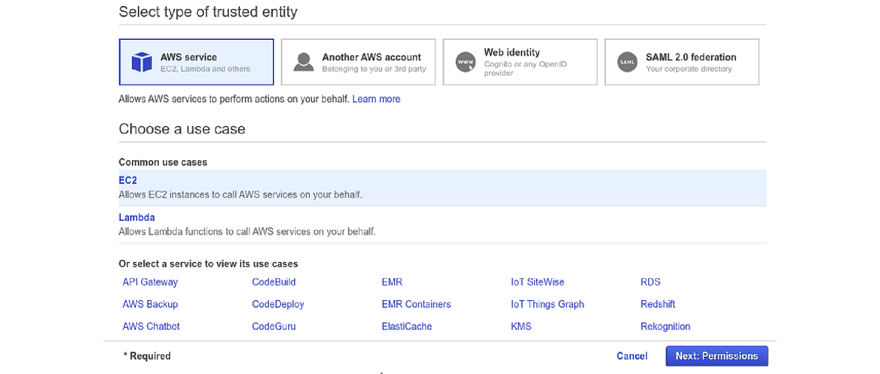

* Now we have to attach the policy which we have created earlier.
* Then we have to write the name of the role. Click on create role.

**Next step is creating user**

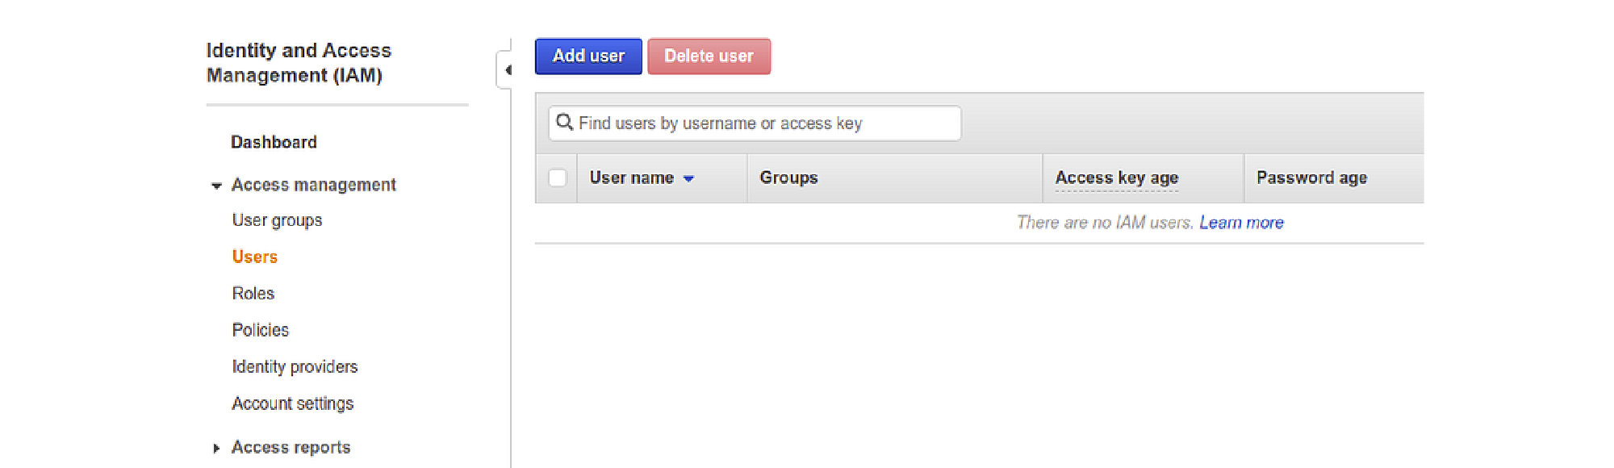

* Click on create user and the write your user name .
* Under select AWS access type select Programmatic access.
* Then select next Permission.
* Under permission select attach existing policies directly.

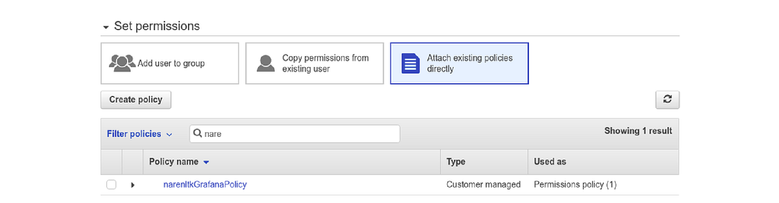

* Search for the policy we have created and then proceed.
* Now you can see Access Key and Secret access Key.
* You have to save that key for later use.

**Now we have to attach our EC2 instance with the IAM User**

* Select the EC2 which you have created earlier.
* Click on Action -> Security ->Modify IAM Role.
* Now under Modify IAM Role select your IAM role which you have created under IAM role. Click on save.

**Now to check that your IAM role is attached to your EC2. Go to security, under security groups your IAM role will be attached.**

**Now get back to Grafana and select data source.**

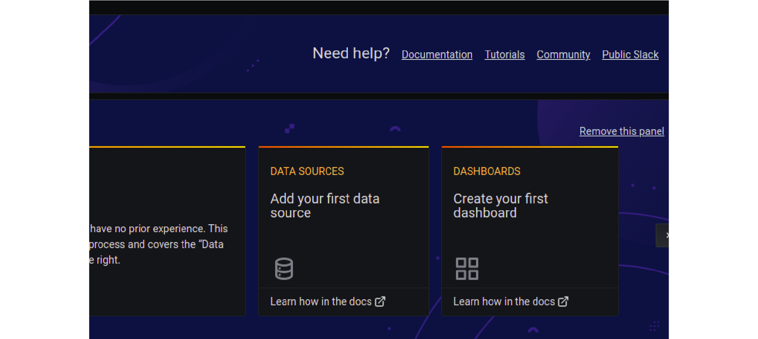

**Here you have to search for cloud watch.**

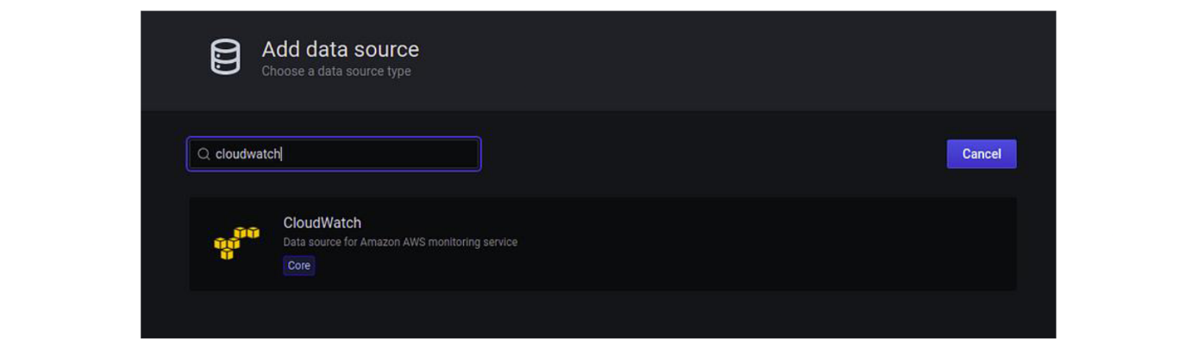

* Now select it to configure the credential details. Here you have to give your desired name.
* Under Authentication Provider select the Access & Secret key.
* Now give the details of the Access Key and Secret Access Key along with the region.

**Now you have to create your dashboard.**

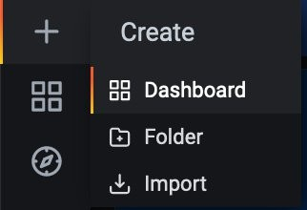

* Now click on Add Panel in the top right corner and add rows.

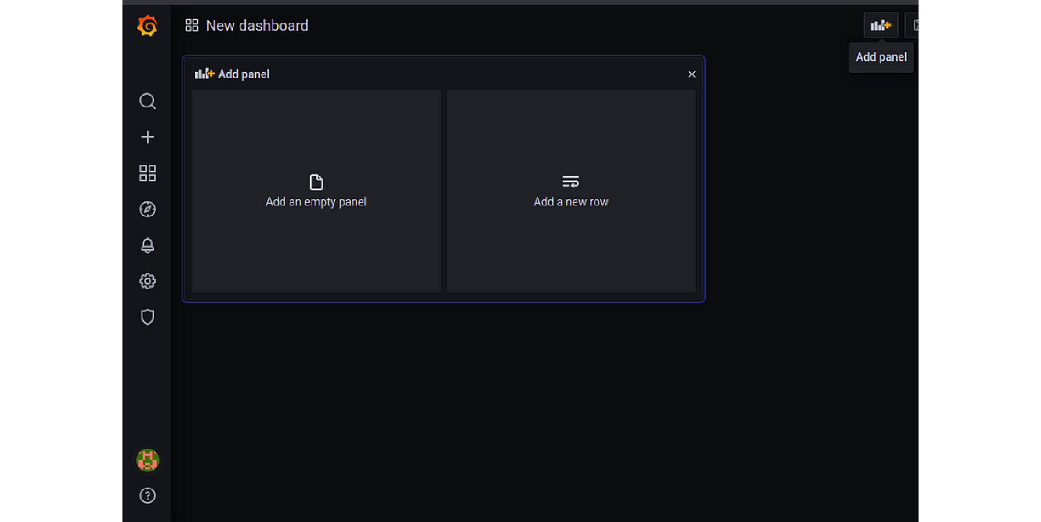

**Now you have to work for CPU Utilization and create your CPU Utilization graph.**

